# 2020 Census EA Framework Selection and Customization

Scope: The Census Bureau is an agency of the Commerce Department

The initial list of possible EA Framework selections could be:

1. The Zachman Framework
2. Federal Enterprise Architecture Framework (FEAF)
3. The Open Group Architecture Framework (TOGAF)
4. Enterprise Architecture Planning (EAP)

**Considerations:**

The Zachman Framework handles large scale complexity potentially better than the FEAF and TOGAF frameworks.

But the Census Bureau Enterprise Architecture scope is only for the individual agency.

So the Zachman Framework may be overkill and not the best fit.

FEAF, TOGAF, and EAP are the remaining frameworks being considered now.

TOGAF might be a lighter weight framework that would be a better fit than FEAF.

But because the Census Bureau needs a customized simpler version for their framework, EAP is chosen over TOGAF with a customized added top level Strategy View and two cross cutting views of Security and Quality (data quality, scalability, reliability and performance).

It is determined that EAP with customization offers the least complexity for structuring the 2020 Census Bureau Enterprise Architecture and Infrastructure Transition Plan.

**Rationale:** EAP is simpler to adopt, adapt, customize and tailor to the needs of the Census government agency.

The 2020 Census architecture is described in the context of the seven domains as shown in Figure 5-1.

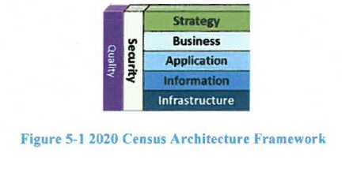

**2020 Census EAP Framework Customization**

The **Strategy Domain** consists of the program vision and mission level business requirements.

The **Business Domain** describes business goals and business operations.

The **Application Domain** describes the application areas and their respective systems and services.

The **Information Domain** describes the enterprise information and data dictionary.

The **Infrastructure Domain** describes the supporting segments and operations.

The **Security Domain** describes the security features and mechanisms throughout all of the other domain areas.

The **Quality Domain** describes the support for data quality, scalability, reliability, and performance dimensions.